Case Report:
Prosthodontic management of flabby ridge using ‘Window Technique

¹Dr. Rupal J. Shah , ²Dr. Abhay H. Machchhar , ³Dr. Sanjay B. Lagdive

1. Professor & Head , Department of Prosthodontics & Crown & Bridge
QR Code: Scan Here
2. Post-graduate student, Department of Prosthodontics & Crown & Bridge
3. Professor, Department of Prosthodontics & Crown & Bridge.
Department of Prosthodontics Crown and Bridge, Government Dental College and Hospital, Asarwa, Ahmedabad, Gujarat
Corresponding author: Dr. Abhay H. Machchhar
Abstract:
Rehabilitation of redundant tissues of edentulous maxillary and mandibular arches is always a challenge to prosthodontists. Often these excessively movable tissues cause difficulty with denture retention and stability. Hence it requires special concern with modifications in impression making procedure. In this case report, a modified impression technique (‘window technique’) using impression plaster is presented for edentulous maxillary anterior flabby ridge.
Key words: Maxillary, Flabby, Impression plaster, Window technique

Introduction:
A ‘flabby’ ridge is a superficial area of mobile soft tissues affecting maxillary or mandibular alveolar ridges. These result from replacement of alveolar bone with fibrous tissues. It occurs more commonly in the maxillary alveolar ridge in anterior area of long-term denture wearers.¹ Flabby ridge occurs in 24% of edentulous maxillae as compared to 5% in mandibular edentulous ridges. Anterior region is more commonly involved in both arches. It is often related to degree of bone resorption and in severe cases this can be the level of the anterior nasal spine.²⁻⁵
Excessively mobile tissues often get compressed while impression making and rebound which cause displacement of denture. This causes loss of retention and stability of denture and also may cause psychological distress to the patient. The purpose of this article is to describe a technique of recording flabby tissues using ‘window’ technique.
Case report:
A 74 year old male patient reported to Department of Prosthodontics, GDC & H, Ahmedabad with chief complain of ill-fitting upper denture. He also complaint of worn out teeth of his old denture. Past dental history revealed that he was wearing removable complete dentures since past 16 years. Old denture examination revealed that it had overextended borders and movement of denture while speaking. Intraoral examination revealed resorbed maxillary residual ridge and flabby tissues present in anterior region (figure 1). So, new set of complete denture was planned for this patient with ‘window’ technique using impression plaster for maxillary denture.
Maxillary and mandibular preliminary impressions were recorded using Alginate impression material (DPI Imprint, Dental Products of India, The Bombay Burmah Trading Corporation, Ltd., Mumbai, India) to avoid compression of flabby tissues (figure 2). Primary impressions were poured with dental stone and plaster (Kaldent Dental plaster class II, Kalstone Dental plaster class III, Kalabhai Karson Pvt Ltd, Mumbai, India) to obtain primary cast for fabrication of custom trays. On the primary cast, flabby area in maxillary anterior region was marked with pencil. Wax spacer was adapted over the primary cast except for posterior palatal seal area and marked flabby area (figure 3). Custom tray was fabricated using self cure acrylic resin (Ashvin Rapid Repair, Dr. Jagdish Lal Sethi, New Delhi, India) with handle attached in the centre of the palate as handle in anterior flabby region would interfere with preparation of window (figure 4).
After border molding was completed, a window was cut in the marked anterior region of palate. The wax spacer was then removed and final impression was made with zinc oxide eugenol (DPI Impression paste, Dental products of India, The Bombay Burmah Trading Corporation, Ltd., Mumbai, India). Excess material flowing in window region was wiped with gauze. The ZOE impression was kept in place and flabby tissues were painted using a brush with impression plaster (Kaldent Dental plaster class II, Kalabhai Karson Pvt Ltd, Mumbai, India) (figure 5) and the area was supported with gauze to avoid fracture of plaster. After the plaster was set, final impression was removed carefully from mouth, washed and disinfected (figure 6). Mandibular final impression was made in conventional manner.
Maxillary final impression was painted with tin foil substitute in the area of plaster to avoid tethering of stone in this region. Maxillary and mandibular final impressions were poured and master casts were obtained (figure 7).
At the time of jaw relation record, the record base was tested for adequate retention and stability. Jaw relations were recorded followed by arrangement of artificial teeth and final try-in was done. Dentures were fabricated using conventional compression molding technique and after finishing and polishing, denture were inserted in patient’s mouth.
Discussion:
The objective of complete denture therapy is restoration of function; enhance aesthetics and maintenance of patient health. If the tissue presents unstable and undesirable denture base foundation it is a challenging task to the clinician to manage this flabby tissue. The three main approaches to the management of the flabby ridge are:
1. Surgical removal of fibrous tissue prior to conventional prosthodontics
2. Implant retained prosthesis (Fixed or Removable)
3. Conventional prosthodontics without surgical intervention.¹
Although surgical removal of flabby tissues provide advantage of firm denture bearing area, it is not feasible in every case as surgical removal would result in reduction of sulcus depth^{3,5} and increase denture base material and hence weight of prosthesis¹. Patient’s general health condition also needs consideration for surgery. Implant retained prosthesis (fixed or removable) has higher initial cost and long-term maintenance cost, and also the time required for treatment is more.⁶
There are various techniques described for recording flabby tissues¹. They are either mucodisplacive or mucostatic. Mucodisplacive technique records flabby tissues in compression so as to simulate these tissues in function and they may withstand masticatory forces better. Mucostatic technique obtains support from other areas of denture foundation than flabby tissues and record them in static nonfunctinal state. There are no clinical evidence that one technique is superior to other. The choice of either is dependent on experience and preference of clinician.
If the flabby tissue is compressed during conventional procedure it will tend to recoil and dislodge the resulting denture. Various techniques are : (1) one part impression technique⁷ (Selective perforated tray): used when degree of mucosal displacement is minimal. Primary impression made with alginate and final impression is made using impression plaster or low viscosity silicone. (2) Palatal splitting using a two tray system: 1964 Osborne⁸, palatal tray impression was made with ZOE and for 2nd tray material used was silicone. (3) Selective pressure flame⁷: it is a mucocompressive technique without displacement. The primary impression is made with alginate or impression plaster. The special tray is constructed and the material overlying firm denture bearing area is softened with a flame before tray is seated under heavy force attempts to replicate functional force and functional impression is made with ZOE. (4) Two part impression technique: Mucostatic and mucocompressive combined described by Osborne. Primary impression is made and special tray is constructed with flabby tissue uncovered. Border molding done and impression of firm supported mucosa is recorded with ZOE paste or medium bodied silicone. Impression of displaceable area recorded by impression plaster or light bodied silicone.^{8,9,10}
This article describes a simple window technique recording flabby tissues in their minimally displaced form and maximum reproduction of details. Choice of treatment modality is made by keeping in mind that requirement of retention and stability of the prosthesis must be balanced along with the preservation of the health of oral tissues for every patient.
Conclusion:
A good impression is always required for optimal prosthodontic outcome. Redundant or excessively mobile tissues require special attention while making final impression. Sound clinical knowledge and operator skill are required for making these type of impressions to fabricate successful prosthesis. In this article, flabby tissues are recorded in their normal undisplaced form and support is obtained from other areas of denture foundation.
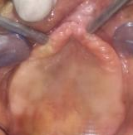
Figure 1: Flabby tissues in maxillary anterior region
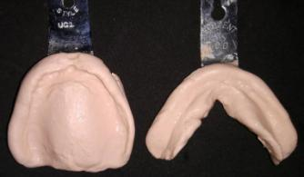
Figure 2: Primary impressions

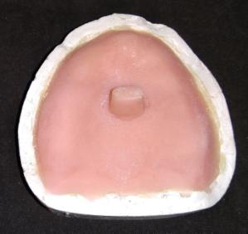
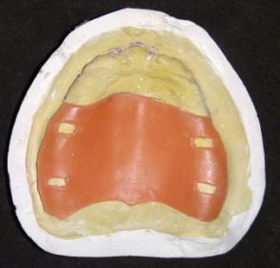
Figure 3: Adapted wax spacer Figure 4: Custom tray with handle in the
centre of palate

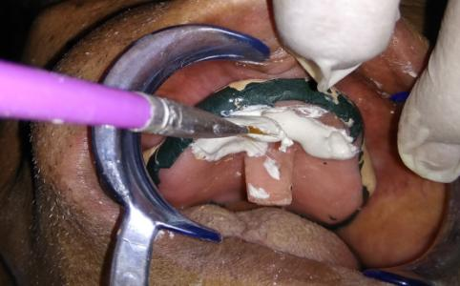
Figure 5: Impression plaster painted on flabby area

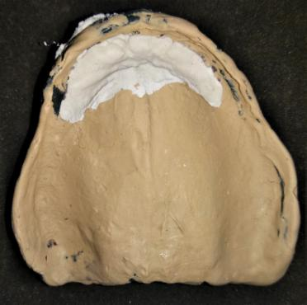
Figure 6: Final Maxillary impression
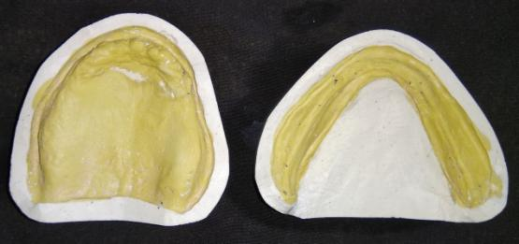
Figure 7: Maxillary and mandibular master casts

Acknowledgement: Author would like to acknowledge Dr. Jigar Sodha.

References:
1. Crawford RW, Walmsley AD. A review of Prosthodontics management of flabby ridges. British Dental Journal December 2006; 199:715-19.
2. Carlsson G. Clinical morbidity and sequelae of treatment with complete dentures. J Prosthet Dent 1998; 79: 17-23.
3. Basker RM, Davenport JC. Prosthetic treatment of the edentulous patient. 4th ed. pp 286-289. Oxford: Blackwell, 2002.
4. Grant AA, Johnson W. Removable denture prosthodontics. 2nd ed. p 61. Edinburgh: Churchill Livingstone, 1992.
5. Zarb GA, Bolender CL, Carlsson GE. Boucher’s Prosthodontic Treatment for edentulous patients. 11th ed. p 36. London; St. Louis: Mosby, 1997.
6. Watson CJ, Tinsley D, Sharma S. Implant complications and failures: the complete overdenture. Dent Update 2001; 28: 234-240.
7. Lamb DJ. Problems and solutions in complete denture prosthodontics. pp 57-60. London: Quintessence, 1993.
8. Osborne J. Two impression methods for mobile fibrous ridges. Br Dent J 1964; 117: 392-394.
9. Hobkirk JA. Complete dentures — a dental practitioner handbook. pp 44-45. Bristol: Wright, 1986.
10. Allen PF, McCarthy S. Complete dentures: from planning to problem solving. pp 48-51. London: Quintessence, 2003.

